“THE SILVER CORD/CHORD”: [INTERACTIVE MULTI-DIMENSIONAL POP-UP ART INSTATLLATION, DENOTING METAPHYSICAL PHILOSOPHIES POST-TRAUMATIC INJURY]

TOKELI BAKER (WHO GOES BY TOKELI, AS THE ARTIST)
Multidimensional Artist: Painting, Music, Film, Scenic Design, and Sculpture
Tokeli Productions
Vista, CA, USA

ABSTRACT
INTERACTIVE, IMMERSIVE MULTI-DIMENSIONAL POP-UP ART INSTALLATION, ENCOMPASSING THEATRICAL/FILM, MUSICAL, AND AESTHETIC (PAINTINGS AND SCULPTURE) INTERPRETATIONS OF METAPHYSICAL PHILOSOPHICAL CONCEPTS BROUGHT ON BY TRAUMATIC INJURY. INSTALLATION EMBEDDED WITH MULTI-FACETED SENSORY EXPRESSION/RECEPTION FOR EXPERIENCER’S SIXTH SENSE/PINEAL ACTIVATION.
INTRODUCTION
June 30, 2017: I fell down a flight of stairs backwards. (Important note: I did NOT land on my head, but instead damaged the right ankle and leg with significant, irreparable damage to fascia and nerves.) This fall resulted in subsequent unrelenting pain, leading to white light and paranormal experiences, not limited to: psychic awareness and abilities, astral projection, lucid dreaming, channeling, clairvoyance, clairaudience, synesthesia, data dumps, kundalini awakening, altered states of consciousness, body vibrations, physical and non-physical manifestations, tinnitus, and prophecy.
This multi-dimensional, mixed media installation represents the multi-sensory story of what happened next.
Please visit www.tokeli.com/portfolio to view all paintings and read corresponding stories.

METHODS: ART DETAIL
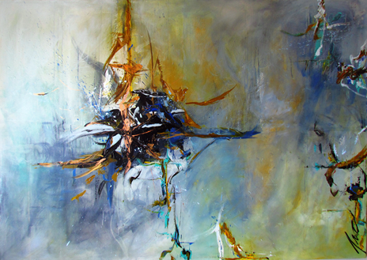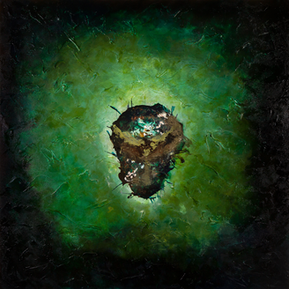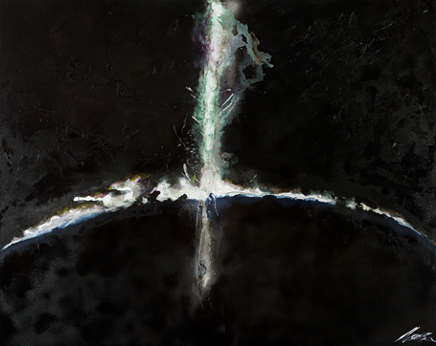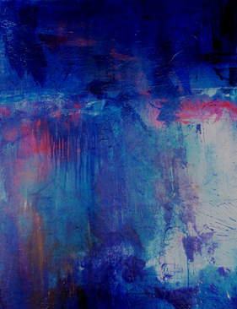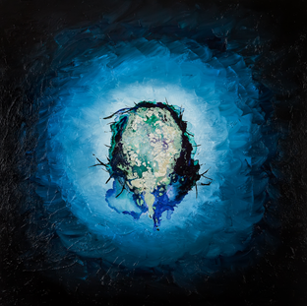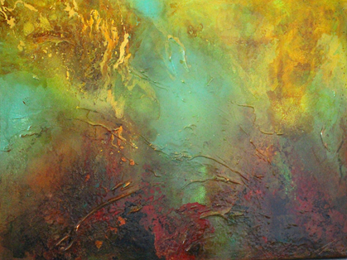
Please visit www.tokeli.com/portfolio to view all paintings and read corresponding stories.

METHODS: INSTALLATION DETAIL

1.) Abstract expressionistic and surrealistic experiential action paintings (which have been synesthetically painted "to music"). Each painting has its own associations: lyrics/poetry, its own metaphysical concepts, a written story, and a piece of original music. Each painting has also been meditated upon for a period of at minimum 30 day regularity process increasing higher metaphysical vibrational "essence" or frequency to each work.
2.) Recorded overhead original music (accompanied by binaural higher frequency (over 110 MgH) ethereal sounds to activate sixth sense awareness in witnesses). Each song has also been embedded with ethereal sounds, see list.
3.) Large screen projectors and/or projections of the artist's original film (a documentary without words indicating images of falling down stairs and subsequent visions and paranormal experiences, see list). Same images projected onto 3D white sculptures of sacred geometric designs, (eg. platonic/geometric solids like the icosahedron, torus, pyramid, sphere, etc.), hanging from installation ceiling. These structures are very lightweight, like Chinese lanterns.
4.) Scenic design element: white organic-looking Vines (shimmering, translucent, seemingly "moving") on walls, floor, ceiling. Think "Stranger Things," but white not black.
5.) Hidden diffusers with water and essential oils (Albizia julibrussin, Helichrysum, Myrrh, Lavender, Rosemary, Nymphaea caerulea, Sandalwood, Frankincense), which aid in pineal activation/sixth sense awareness for the experiencer.

Artist Self-Skepticism
Before June 30th, I was not interested in anything ethereal. I was, however, quite interested in the brain, specifically the brain’s recorded intersection between sight and sound. I’m an experiential action painter, an abstract expressionist painter who also composes music. I “see” music and I “hear” colors, although it's technically different: I must be emotionally MOVED by the material (fear, love, passion). When I FEEL something, I experience this form of synesthesia. In addition, there is always a story associated with every image and every sound/song. We all have this ability, but we do not perceive it in real time.

Having previously only believed in things which presented themselves directly in front of me, the only course out of skepticism was to fall down a flight of stairs and then personally begin experiencing these “outside the norm” (paranormal) sensations and happenings. I’m the same girl they interviewed on the international atheist radio program (for my music work); I’m not pushing bibles here, nor am I a “spiritualist.” I’m still a skeptic, and I’m still a cynic. I am questioning, self-doubting, second-guessing, and researching and rabbit-holing. However, I’m more open than I was before June 30th, because seeing and feeling really is believing. I saw it. I was there. Do you want to see what it looks like (to me) on the other side?

RESULTS
Sketch of Installation Plan
Includes paintings and the hanging sacred geometry “sculpture” upon which the film will be projected. Also included: installation overhead music and binaural sounds, installation floor/wall sculptured “Vines,” altered book for witness tactile interaction, and diffuser fragrances.

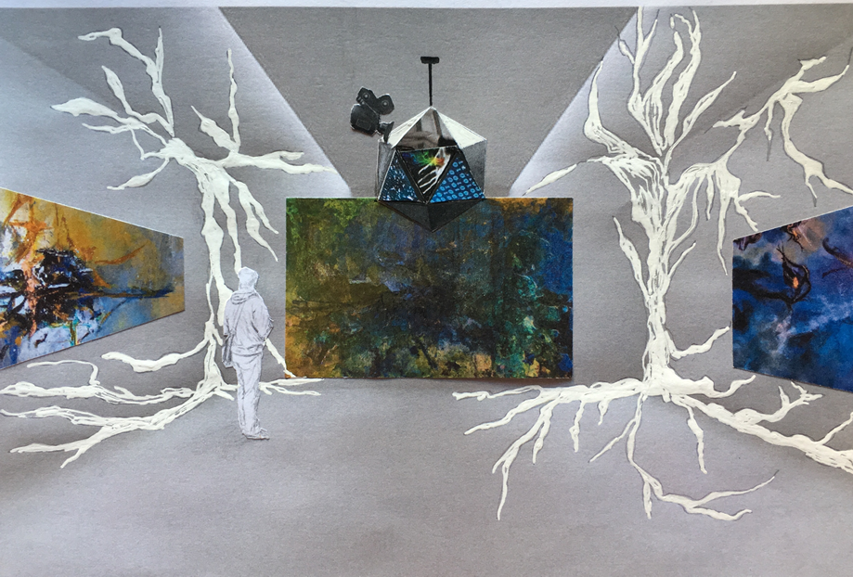
Fig. 1 Installation Plan sketch.

REFERENCES
List of Sounds for Film, see attached.
List of Images for Film, see attached.
www.tokeli.com

List of images (overlays) for Film

Nature
War
Animals
Wind
Trees
Self-Realization Fellowship monks and koi pond
Torus
Icosahedron
1’s and 0’s
Videogames and holograms
Kundalini yoga and chakra mudras
Amazon natives
Ancient Egyptian hieroglyphics
The pyramids
Machu Pichu
Other international sacred sites
People meditating
Jacques Fresco’s images and also the Venus Project
Underwater snorkeling images
Vertical building gardens
Tesla
Free energy
Egyptian ankh
Symbolism
Crop circles
Maps of imaginary places
Atlantis and Lumeria
Rare Birds
Dinosaurs
TONS of sacred geometry
Futurist architectural designs

List of sounds for Film
Ambient sounds to include with the music, fading in and out.

Nature
Wind
Bird calls
Trees rustling
Animal sounds
Metalurgy
Steel bars banging against one another
Watch ticking
Whales
Underwater sounds
The sounds of the planets (look it up, they each make a different sound frequency!)
Human heart beating
Harp sounds
Paintbrush scraping
Dinosaur VR
Footsteps
Scary sound effects: echo of
Computerized children’s voices
The ringing in my ears
Binaural beats!
Highest vibrational frequency sounds (online)
Sound alchemy (hermetic sound science)
Third eye opener sounds
Pineal activation tones
Bird wings flapping
Church bells
Gregorian chant
Tuvan throat singing monks

CONTACT:
Tokeli Productions
www.tokeli.com
tokeli@tokeli.com
619-519-1558

